(Approx. 406 words)

Family Tree Maker 2011 (Part 3)
Review by Mary Phillips, Secretary, Icon Users Group, MO
The ICON-Newsletter of the Interactive Computer Owners Network www.iconusersgroup.com
mphillip1.mary (at) gmail.com

Tab 3 Places — Each time you enter an event in a person’s life you have the opportunity to enter the name of the place where it happened. FTM makes a master list of these locations and makes available Bing interactive maps much like Google maps so that you can view road maps and satellite images and even get the latitude and longitude of the places if you know exactly where the event took place. Names of places you enter are compared to a Place Name Authority that includes the city (or township, or province), county, state, and country.

There are three sections of the Place tab: Manage Places, Location Maps, and Associated People. The Manage Places section has two options — 1) the Place names that have been entered, and 2) the names of the People. The map below, because I have no town, shows the middle of Lawrence County on a Roadmap in 2D and the drop
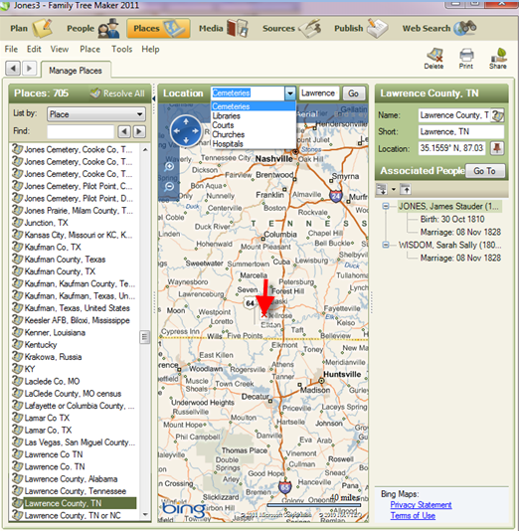
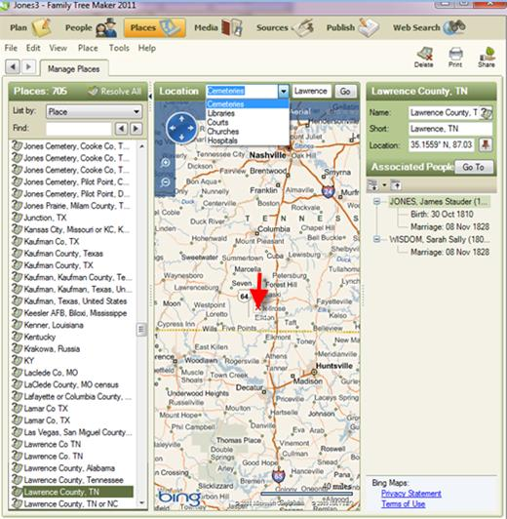

down box lists Cemeteries, Libraries, Courts, Churches, and Hospitals — all places for which you can search on the map and where you might find records. Map tools include zoom in/out, directional arrows (You can click and drag the map or use the mouse wheel to scroll in different directions.), Aerial view is a satellite image and with Labels turned on the towns are listed. Bird’s eye view is like Street View in Google Maps; landscapes and houses can be seen.

The question marks beside the place names in the left section simply mean that they are different from the Place Name Authority or aren’t listed in the PNA. Right clicking on a place name provides a menu that allows one to Resolve the name or change in some way. There is also a Resolve All button next to the number of places.
Two Associated People are shown with Lawrence County, TN and clicking on the plus sign expands to show the details.
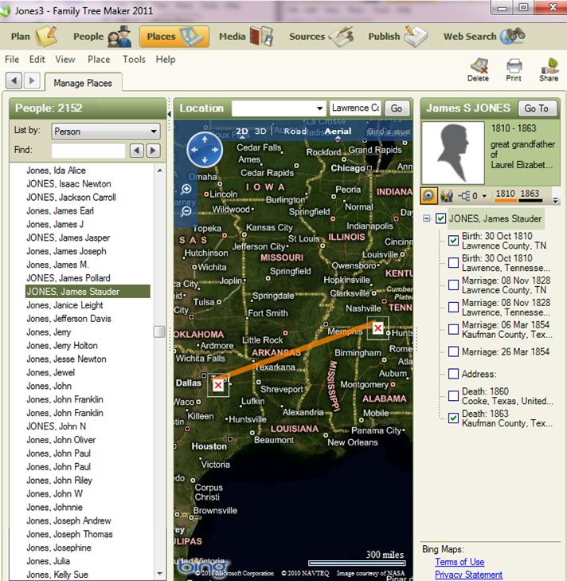

Clicking on Person and Aerial w/Labels shows events in the individual’s life, lives of the immediate family, or lives of up to four generations. The line in the middle marks from where he was born in Lawrence Co, TN to where he died in Kaufman Co, TX.

The reason some facts are listed more than once is because I had more than one source for items.

